Dooming the American Way of Life to Rapid Extinction: The Science Teacher in 1943-1963

Abstract
Common perception holds that the October 1957 Soviet launch of Sputnik created urgency for reform in American science education. This perception likely arises from a study of popular periodicals at the time. However, pre-college science-teacher journals tell a different story. Urgency for reform had been central to conversations of American science education for at least 15 years prior to Sputnik’s launch. This sense of urgency is clearly demonstrated within the primary science teachers’ journal, The Science Teacher. The Science Teacher (TST) is the most widely circulated science-teacher journal, and because it does not focus on a narrow discipline within the sciences, it reaches a general audience of secondary-school science teachers. TST publishes peer-reviewed articles from a variety of stakeholders in science education: administrators, educational researchers, scientists, industrialists, and teachers. Thus it allows historians to understand a key but understudied community in the history of American science: the pre-college science teacher. By closely examining TST, historians can get an understanding of the so-called crisis in science education from inside the science- education community.

Between 1943-1963 research scientists, representatives from industry, and others outside the teaching had an ambitious list of demands for American science education: win World War II; instill a sense of democratic duty; stop venereal disease; prevent cancer; terminate the emotionally instability of young minds; preserve high standards of living; teach all students equally; teach the most talented very equally; guide students toward racial tolerance; and achieve “intangible objectives.” Science teachers heard a unified message from industry, the science research community, other teachers, and the public that they had failed their obligation to American students, but the messages conflicted when it came to how they had failed. In the pages of TST, Sputnik hardly caused a stir. The debates, stories, criticisms, and urgency remained the same before, during, and after the launch of the infamous satellite.
During World War II, science teachers were preoccupied by their role in the total war effort. Because, as the journal explained, this war was the “physicists’ war,” the articles in TST overwhelmingly portrayed science education as central to the war effort. TST articles carried a sense of urgency, frequently petitioning teachers not to disappoint the future of America. At the same time, during the early to mid 1940s, TST took a great interest in Soviet science and science education. This early interest did not initially frame the Soviets as a menace; rather, TST framed Soviet science as a gentle rival. The journal’s interest in Soviet science and education seemed to wane as the nation’s interest grew.
As soon as the war ended, new headlines for the education crisis took the place of the war effort. This time science teachers were told they were responsible for creating a manpower shortage. There is a current perception that the discussions of the manpower shortage were connected to the space race with the Soviets. However, TST from the period suggest the origin of the manpower shortage was a wholly American problem. In fact, as I will illustrate, some scholars of the time argued that America’s suggested solution to the manpower shortage-separate tracking of scientifically “gifted” students-may have been white America’s response to Brown V. Board of Education.
After the launching of Sputnik, there was merely one more symbol of the supposed failure of American science education. With each wave of criticisms, some teachers expressed hope that the public would hear their pleas and suggestions on how to ameliorate education. Teachers advocated deep systemic changes such as improved pay, smaller classes, fewer non-teaching assignments, and better laboratory equipment. These suggestions fell on deaf ears. Industry and government spent a great deal of money on the production of curricular materials, pamphlets, film strips, and other “neatly packaged” items. Professional educators were, for the most part, left out of the production of these materials. When the materials failed to reform science education, teachers were left with the blame.

The science education crisis during World War II
TST devoted its pages nearly completely to the total war effort. Article titles such as “Insects at wartime,” “Army needs as they relate to science” and “Teaming up the science club in a war program” are characteristic of TST articles during the period of 1943-1945. A vocal majority expressed certainty that science education played a key role in winning World War II. Many, if not most, of the articles and advertisements in TST were concerned with the role science education played in the nation’s war effort. Contributors wrote consistently that science teachers assume responsibility for pre-military training of young men. Articles often addressed science teachers didactically, as though they were mere conduits for information, rather than innovative professionals. For instance, one series of TST articles cut out the teacher all together, and spoke directly to the young high-school men.
If you are normal, you look forward to the establishment of your own home. But military life separates such men as you from the normal contacts of home and postpones the time when you can satisfy the normal mating instinct in a decent manner. Ever since there have been armies, they have been followed by droves of loose women and other human dregs, ready to exploit and feed on the animal instincts of young men.

Why did this article appear in a science teacher journal? Such journals function to communicate professional concerns and share ideas for lesson plans and laboratory activities. This particular series on military hygiene is striking because such personal advice, with only loose connections to anything “scientific,” addresses young men under the guise of science education. The writer and editorial board makes a curious that a science teacher would be an appropriate vehicle for such a message to incoming military men. This article illustrates the prominence and near obsessions with the war seen in the journal. Even the normal convention of audience, and what qualifies as “science” education, was flouted in service of the war. More importantly, it illustrates the perception many people had toward teachers: they were only a medium that needed a message.
Some of the contributors’ ambitions for science education’s potential to alleviative current social woes were fanciful. A representative from Westinghouse School Services, Bertha E. Syle, wrote in her 1944 contribution to TST’s yearbook about science’s ability to serve as a mental and emotional prophylactic that could put an end to future wars. “One of the greatest problems which the directors of the armed forces have had to meet…is that of training men who are emotionally unstable.” Emotional instability is found not only “in our fighting men, but many of our civilian population, due to a lack of sufficient knowledge of the physical laws.” This same instability, she tells us, afflicts “national figures such as those of Hitler or…the …leaders of Japan.” The author tells readers that the solution to emotional instability “is the use of habitual intelligence that is best taught and understood by the study of science.” Syle writes that not only will the war favor the United States, but juvenile delinquency can be wiped out, once science teachers help high school students find “the answers to the true meaning of life within the classroom laboratory.” Syle’s article is indicative of the impossible expectations people had for science education: the notion that knowledge of the natural laws somehow addresses mental or emotional deficiencies.
Other contributors to TST criticized a perceived failure of science education. “In this war our government has had many difficult problems to solve - and in nearly every case it has been the scientist, with his applications of scientific methods, who has provided workable solutions,” wrote one high school teacher. He attempted to convince readers that these “workable solutions” would only come about when teachers stick to teaching the “facts” in science courses. The author explained that teaching facts has recently drawn “scorn by…modern educators,” who would prefer to offer “denatured and easy courses.” The author argued that he and others in his pedagogical camp had provided the nation with a great service and that “reports from the armed forces” confirmed that sound and basic training in the sciences was vital to the nation’s war effort. The author did not provide details about what these imperative “facts” or “basics” were, nor did he give any further details about his course structure, other than to tell readers that it was rigorous - and precisely what the country needed.
Contributors agreed that science education was important, but not about why it was important. As evidenced above, one author is optimistic that scientific inquiry soothes savage emotions and facilitates the discovery of scientific “truths.” She argues that this will prevent mental instability and future wars. Another author takes a more practical approach, writing critically that some military men cannot serve their nation as well as others because they have not been taught the “facts” in science. While these two articles provide a different rationale as to why science education is so important, both make it clear that the stakes were very high. America was depending on science teachers for a better future.
Advertisers in TST capitalized on the urgency of using science education in service of the war. “Science Teaching is War Production,” wrote an advertising spread for the College Entrance Book Company, which offered, “text assignments, exercises, experiments, drills and texts for basic, but war enriched course [sic].” Textbook publisher McGraw Hill invited teachers to review textbooks such as Elementary Meteorology and The Earth and Its Resources as “books for Wartime Science Courses.” “Microscopes go into battle, too,” (Figure A) claimed the Spencer Lens Company. The same ad campaign continued throughout the volumes of TST featuring headline texts such

as, “The War…and the Physicist (Figures B &C).” The photograph from this ad appeared again nearly a decade later with the new caption “Understanding starts here.” The company reused and repurposed the image of the physicist, serving as a visual metaphor for the way in which science and science education were reused and repurposed by TST contributors over the years. Just as the photograph of the physicist stayed the same, so did the rhetoric of crisis and urgency in TST. Only the headlines changed.

Figure A
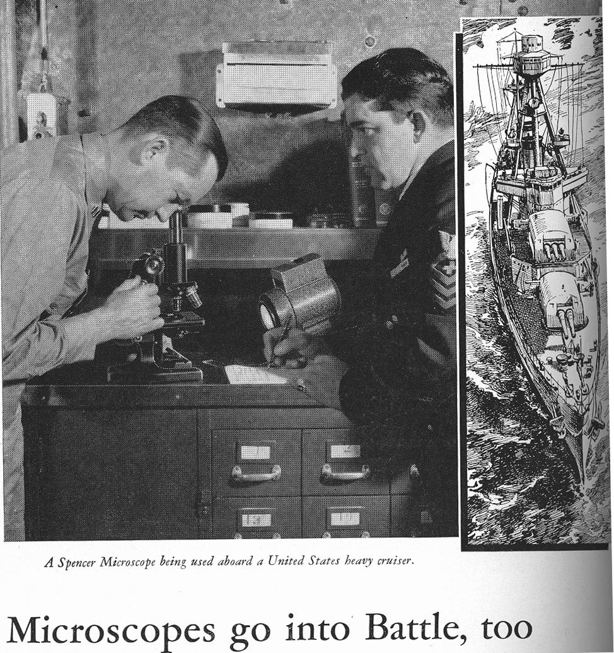

Figure B (from 1945)
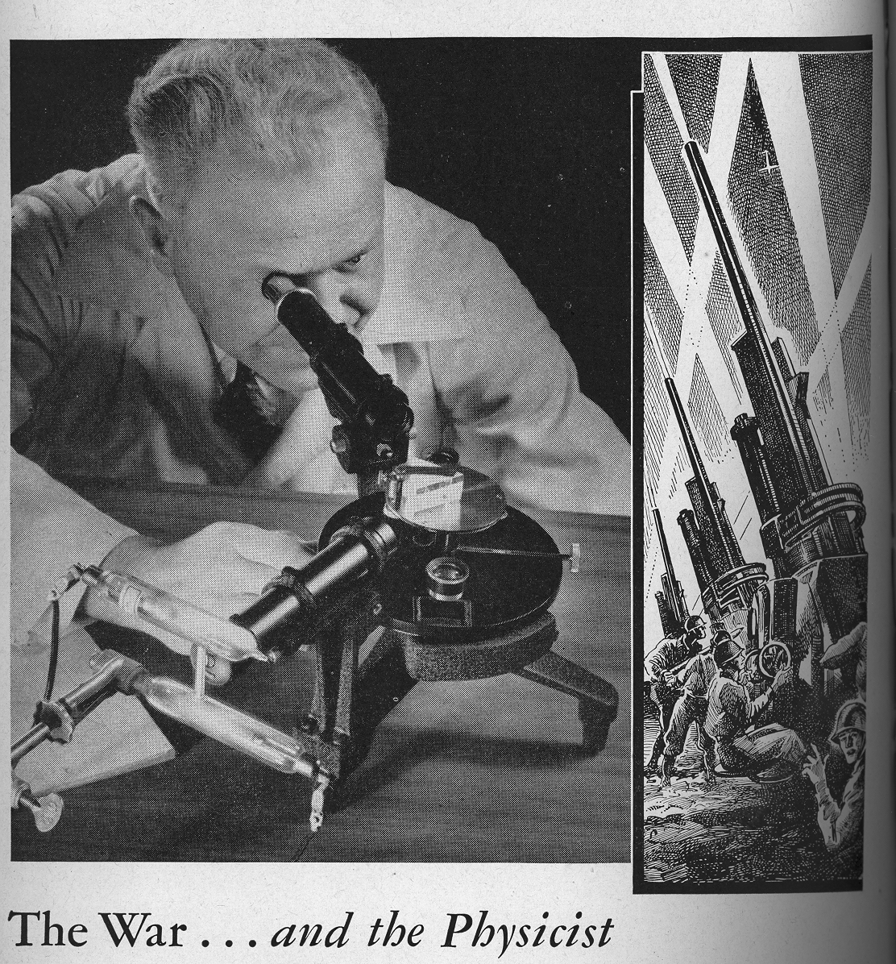

Figure C (from 1957)
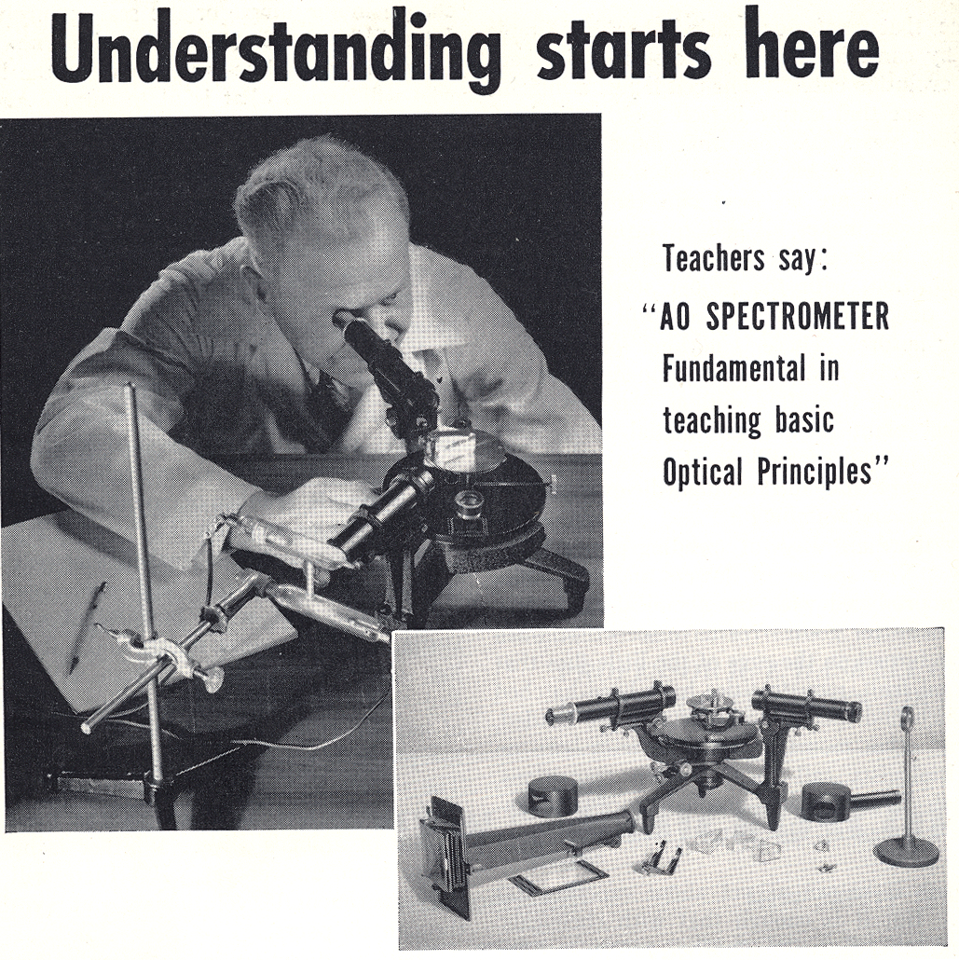

Attention to science education during WWII may have underwent scrutiny, but some science teachers expressed gratitude for the significant public interest in science. For many teachers, the advances made in civilian and military technology engaged students by demonstrating the “immediate worthwhileness” of science. Some teachers even expressed anxiety that students would lose interest in science once the war ended. High school science enrollment peaked at 71.7% in New York City schools during the autumn of 1944. The New York Schools science supervisor wrote that he was certain that “ this increase was due entirely to the impetus of the war years.” But when the war ended the criticisms and scrutiny of American science education found new causes.

The manpower crisis
With the war over, science education soon faced a new crisis. It found a new purpose in the manpower shortage: science teachers were failing to prepare students to work in the industries that were imperative to the high quality of American life. While the “manpower” shortage is often viewed as synonymous with the technology races against the Soviet Union, readers of TST during the 1950s would have read about the manpower shortage as an entirely American, and mostly civilian problem. For this reason, it is necessary to treat them separately. The manpower shortage brought attention, especially financial attention, to the science teachers. TST had a number of corporate sponsors from applied sciences industries. Many of these sponsors contributed monetary awards directly to teachers. Sponsors such as Bell, Westinghouse, General Electric, and Ford were ubiquitous in the advertisements and articles of TST. They funded continuing education workshops, awards, grants, television programs, filmstrips, and student science fairs. Their sponsorship shaped curricular ideas about science teachers and technology. Industry had access to the increasingly contested territory of science education. Why was science education important? What was it good for? Industry’s answers came from their TST advertisements.
Bell Telephone Laboratories frequently placed ads in TST featuring famous scientists such as Darwin and Einstein in addition to contemporary industrial researchers. Despite depicting theoreticians, the text explained that Bell researchers were improving the quality of American life via applications of scientific research. Textbook companies printed titles such as Chemistry — Man’s Servant, that clearly pointed students toward an applied epistemology of science. Corporations offered complimentary learning materials to teachers. General Motors advertised a guidance booklet for teachers and counselors featuring a young boy, scratching his head in front of blue-print style drawings of a bubbling flask, Bohr-style atom, and various other scientific zigzags with the large title, Scientist or Engineer? (Figure D) GM answered that question in an earlier advertisement proclaiming “News for Science Students!” The headline of the “news” was that “ high school friction studies help GM engineers build better car engine bearings.” “Yes, — today’s successful automotive engineers are yesterday’s hardworking science students. And tomorrow’s automotive engineers will be those of you who take advantage of your school work.” Westinghouse announced “The world is looking to young engineers” and offered science teachers a free poster of a young, clean cut white man (Figure E) staring at a horizon where he sees various factories, an electric train, airplanes, and electrical towers. Trees are sparse, bushes are strategically landscaped, and no birds or animals appear in this orderly, controlled, modern world. The engineer was a creator, a hero. By the middle of the 1950s when federally funded research scientists became involved in curriculum, industry already had the ear of the science education community. They invested a great deal of money in fostering public science education that would best suit their needs.

Figure D
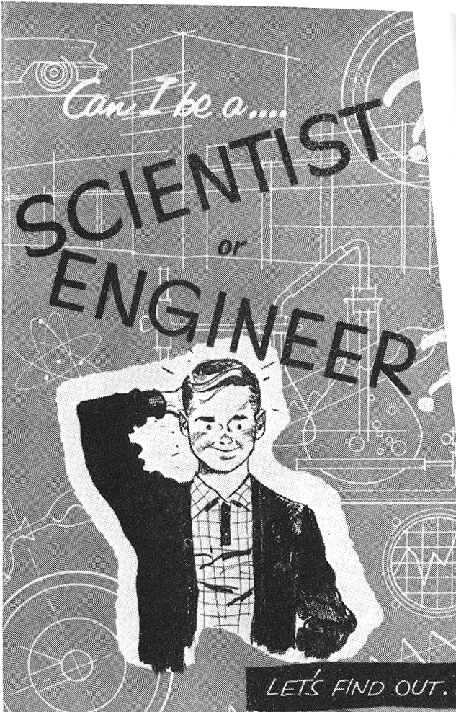

Figure E
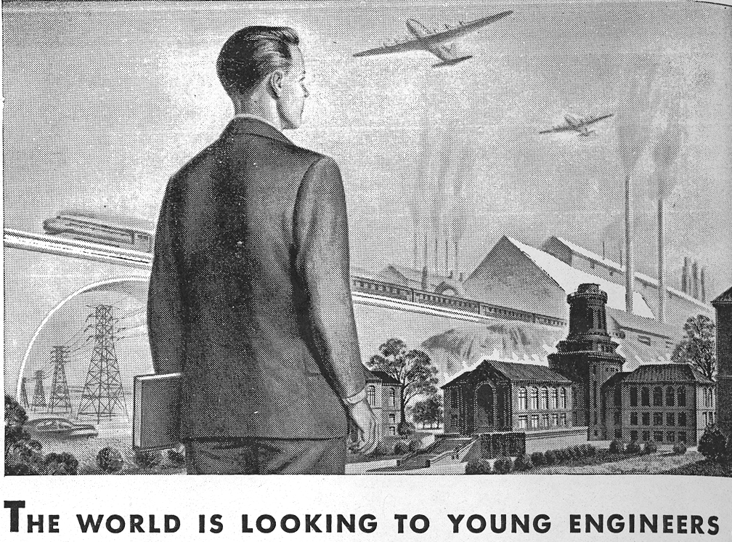

Most teachers embraced the help with curriculum materials and continuing education provided by industry, but a few contributors were skeptical toward the aid. In a special pull-out section of TST, the National Science Teachers Association (NSTA) posed the following question: If science education was so bad, how did the US create so many successful applied science industries in the first place? In focusing on education’s culpability for the manpower shortage, no writers address the more obvious reason for the shortage: rerouting potential scientists into the military for WWII. Industry representatives were not shy about writing in to TST in order to complain about the lack of scientific talent, but none of them ever printed any research findings or statistics to support these claims, much less specific ideas toward improving science education. A high school teacher conducted the most in-depth analysis appearing in TST on industry needs. His study strongly suggested that writing and communication skills, not scientific knowledge, were a deficit according to industry employers. A Monroe High School science teacher in Rochester, NY conducted a survey of various research companies and industry asking, “Educationally, What does Industry Need?” A steel company reported, “eight out of ten [current employees] cannot write a well composed business letter.” The company needed employees with “excellent command of English, both oral and written.” A technical research company director “summed up his chief criticism of many research men with the exclamation, “For God’s sake, English! He felt that the greatest weakness of some men in scientific pursuits is the inability to use the English language properly.” A chemical research company stated that, “Good English usage is demanded first and foremost.” Finally, the author reported a chemical products company “prefers research men with a well balanced liberal arts background. ‘We want our people to be well educated and have a good command of English with the ability to express themselves succinctly.” The author concluded that the first educational implication was, “increased broad training in the fundamentals of science…”, despite the data he gathered clearly demonstrating otherwise. TST received and disseminated many curricular materials from industry that encouraged the teaching of applied science. However, the above survey results reflect a disconnect within industry regarding employee weaknesses.
The most strongly supported solution to the manpower shortage was to give special instruction to “gifted” or “superior” students. Proponents of the separation of students pled that gifted students not be slowed down by being in a class with “retarded” students. This included not only mentally retarded students but also “educationally retarded students.” Educational retardation was linked to “conditions of the home” and “regularity of attendance.” Proponents of special courses for superior students wrote at length to TST that in order for science education to be equal, it must be separate. For these writers, science was primarily for the superior student. What made students superior in science was the subject of a great deal of research, study, and speculation. Frequently identified traits included having parents with college and post-graduate degrees, a financially comfortable home, and personally acquaintance of scientists. “Our grievous general error in science is to assume that all students are to be given the same opportunities in science…equal opportunity need not mean uniformity of opportunity,” wrote one biology teacher. This did not mean that students who were not gifted ought to bypass science instruction, “ not to imply that a number of students whose I.Q.’s are of the nature of 100, or slightly above, may not contribute to science. Indeed they do as technicians.” Writers discouraged “dry repetitive coursework” for superior students, but prescribed as necessary for “retarded” students. The discourse of talented students appeared in advertisements, too. Advertisers frequently used the notion of “not holding students back” to sell their curricular materials. As the space-race progressed, advertisers used the imagery of space travel as a symbol for a scientific mind bound only by the confines of a dull classroom (Figure F).

Figure F


Financial attention targeted separate courses for gifted students. No wonder some teachers eagerly attached themselves to the “talented” students; industries invested heavily in gifted education. A former president of the NSTA —who also served as principle of science education in New York City schools — wrote on this topic on behalf the Ford Foundation. In 1953 he argued,
Not more than a third of the individuals in an age group can be educated for intellectual work…[d]ifferential education for [superior students] is not preferential treatment. Equality of educational opportunity should not mean equality of education exposure. It is more important that each individual attain his maximum achievement, than that all shall reach some minimum achievement. (original emphasis)

The remainder of the article described the various funded opportunities the Ford Foundation would grant gifted students and their teachers. The author and Ford were confident that this separation of students was the best and only way to fulfill a shortage of scientific and technical manpower: “Civilization and [the American] way of life are at stake.” It is nearly impossible to look at these articles and ignore the socio-economic overtones regarding who is entitled to an exemplary science education. These articles are contemporaneous with Brown V. Board of Education. Yet there are no references to the trial, the issues as stake, the outcome, or the trial’s implication upon these recommendations for separate education. Brown V. Board addressed separation on the basis of race; separating “talented” science students used social class as a criteria. During a time when the nation was realizing that separate could never be equal, science educators were told the contrary. For an educator’s journal, it is curious to see no overt commentary on one of the greatest educational news stories of the day. It seemed TST had a blind-spot in Brown V. Board of Education.
Not all teachers agreed that targeting specialized science education for superior students served public interest. Some contributors to TST longed for the days when it was acceptable to teach the “average” student; when science was for all their students. These teachers recognized and resented the elitist reputation science classes, especially physics, earned among students. Those in favor of special courses for gifted students threatened gloom-and-doom to generate support for their cause. One teacher attempted a similar strategy in order to generate support for a more democratic vision of science education:
…consider this matter. Joe Smith is a truck driver and knows nothing about inertia. So he throws a hammer onto the shelf right behind his head and loads his trucks behind the cab with some heavy iron ingots, stacked up high. Then and there, knowledge of inertia and principles of motion may mean the difference between life and death for Joe Smith. On a sudden, short stop that hammer may hit him in the head and kill him…. Physics is a life and death subject (original emphasis).

Industries were eager to furnish financial support for gifted students and supply teachers with curricular materials designed to attract bright students toward careers in engineering. However, despite their own complaints and criticisms wielded against public schools, balked at the long term, systemic investments school leaders recommended to bring about improvement. The executive secretary of NSTA at the time, Robert Carleton, expressed the only overt skepticism of industries’ intentions in science education in TST. In a September 1959 editorial, Carleton worried that a number of industries, such as General Motors (GM), were eager to cooperate with schools on local levels but fought very hard against providing continuing substantial financial support for schools. GM would send free pamphlets designed as teaching aids and would send industrial engineers to speak to Michigan students. But when Michigan schools brought their dire financial situation to the public, the president of GM published protests in Detroit News, “Higher taxes will drive industry out of the state!” Carleton noted that in the same paper, during the very same week, another “General Motors executive was quoted as complaining that our schools were doing an inadequate job of training scientists and engineers.”
While many stakeholders in science education were preoccupied with the way science education both caused and would solve the manpower shortage, a different crisis was brewing. The relationship between the United States and the U.S.S.R was becoming more strained. While Americans were thoroughly convinced that Soviet politics, attitudes, government, and theology were wrong and inferior to the U.S, many Americans had no trouble saying that Soviet science education was superior.

Science education and the crisis of Soviet superiority
By the time Sputnik came along late in 1957, it was merely configured by popular press as new evidence for the failure of American education. Foreign enemies threatened American scientific superiority and contemporary news told the public that American education was to blame.
TST shows evidence that American science educators were interested in Soviet science and technology long before Sputnik, during WWII. TST channeled the Soviet rivalry into a friendly one that, some writers hoped, would inspire American science teachers and students to excel. In the mid 1940s, an advertisement found in the back of TST announced two “Science Movies…for inspiration and motivation:” Glimpses of Soviet Science (I) and Glimpses of Soviet Science (II). In 1944 when few American scientists expressed any interest in pre-college science education, a Soviet physicist contributed to TST. A.F. Ioffe, “one of the most prominent physicists in the U.S.S.R.” and recipient of the Stalin prize for his work on semi-conductors, brags to American science teachers:
Compared to the situation abroad, the organization in the U.S.S.R. is a model which the most advanced nations can only dream of. As a result, to the surprise of many, not only of our enemies, but also of our friends abroad, the technical power of our army was vastly higher.

According to Ioffe, the Soviets’ dedication to their work in science was unrelenting, and the most exciting advancements in Soviet science were also the most secret:
Unfortunately, I cannot mention the most important and interesting tasks of contemporary physics. Naturally, the most important, the more enticing, new and interesting the given military subject, the less it is open to scrutiny. I cannot go into the details of the truly heroic work, which many scientific workers are performing today…but I was a personal witness of how a whole group of co-workers over a period of three weeks did not leave the laboratory, working there day and night. Now and then, collapsing.

An annotated bibliography of “Soviet Science in Russia” appears in a 1945 TST and is accompanied by the editor’s reassurance that “this intense interest in Soviet science is… healthy” for American teachers because “…the strides made within a generation ushered in by the widespread illiteracy and backwardness of old Russia staggers the imagination.” Good Americans, the editor tells us, ought to use Soviet success as a stimulus to work harder for “ever greater science achievements in America.” Soviet success in science was used to instill a sense of duty for American students to excel.
During the mid to late 1950s, the American scientific research community became increasingly interested in educational research and what it revealed about the (perceived) superiority of Soviet science education. Articles on the topic made their way into the main periodicals of the science research community. A pre-Sputnik May 1957 article in Science described Soviet education and the use of educational research. The author, a professor of psychology at Rensselaer Polytechnic Institute, wrote about the Soviets’ pride in their educational success and commitment to repairing any shortcomings in bringing up “youth as active builders of communism.” The author reported that in 1936, Soviet schools prohibited separation of “retarded” children from normal coursework and put an end to the practice of seeking the most “gifted” students to place into accelerated tracks in school. The Soviet assumption, Science was told, is that all pupils are capable of learning. Incompetent teachers carried the blame for any student failures. Scientific content was stripped of any erroneous “human interest detail” detracting from learning the scientific principles. The applications of all scientific principles were considered top learning priority. What is notable about this report is that many of the features of Soviet science education described here (de-tracking students, the focus on applied science) were in direct opposition to the recommendations made by the most vocal critics of American science education. Despite the fact that Science reported Soviet curriculum as being focused on applied science, physicists were already involved in writing a new high school curriculum emphasizing “basic” science.
Contrary to Soviet claims about equal education for all students, the stakeholders advocating the need to segregate students based on “ability” and “talent” became more vocal after Sputnik. Bruno Bettelheim, a University of Chicago Professor of Education and school principal best known for his controversial theories on autism, wrote an article in a 1958 The School Review arguing that Sputnik became an argument to re-segregate schools. “The broad interest in schools, segregation, and Sputnik is not accidental, wrote Bettelheim. “It was the feeling of defeat that Sputnik aroused that set off insistent demands, first for more and better scientists and, second, for special provisions for the education of the gifted.” Of course, science educators have been hearing, and making these very same demands since the end of WWII. While Bettelheim’s argument that Sputnik was used to justify segregation of schools (especially Northern schools) is a compelling one, he mistakenly attributed these justifications as unique to Sputnik, when , as we’ve seen, justifications for segregations predate the launch of the satellite.
Meanwhile, in the science community, physicists were well on their way toward creating curriculum intended to foster an appreciation of “basic” (or “pure”) research in science. Sputnik’s launch reaffirmed to many that the United States had “fallen behind” the Soviets in science. But the alleged superiority of Soviet science education appeared only as a rhetorical device. Critics of American science education continued to argue for their own pedagogical preferences. Soviet schools were never seriously considered to provide legitimate solutions to America’s educational “problems”. Americans could envy Soviet science education, but there was no interest in emulating it.

Science isn’t a sputnik
With the launch of Sputnik, many Americans became convinced that they lost the competition of scientific superiority. News was widely circulated claiming America’s “namby-pamby kind of learning” would doom the American way of life to “rapid extinction.” These criticisms were identical to the ones made during WWII, and later after the war regarding the shortage of workers in industry. The executive secretary of the National Science Teachers Association (NSTA), Robert Carleton, wrote an extended editorial in TST in December 1957 that, “the sputniks have shaken us out of our complacent attitudes toward schools and teachers.” Throughout Carleton’s tenure as the executive secretary of NSTA, he consistently demonstrated great insight about the relationships between science education, the public, and the scientific community. Carleton wondered how it was possible that for everything science was, it became synonymous with a 184 lb artificial moon.
On the one hand, Carleton considered that the sputniks might finally rally the country to get behind the systemic changes necessary in order to help science education draw and sustain quality teachers. Would the country give teachers what they “ have been asking” but the American public has been “unwilling to pay for during at last quarter of a century?” Perhaps this new round of scrutiny would convince the public to invest in changes for science education: an improved salary, smaller class sizes, a bigger budget for lab equipment, and “reasonable teaching schedules and non-teaching assignments.” Better working conditions for teachers, Carleton reasoned, might draw and sustain highly qualified teachers.
On the other hand, Carleton knew better than to be overly optimistic about the potential the sputniks had to initiate positive changes. He was anxious that the national panic over Sputnik would merely translate into something he had seen before: a “neat package of information to be swallowed by students,” rather than any serious investment in school improvement. Instead of working to increase teachers’ pay, lighten teaching loads, and provide substantive continuing education, Carleton warned, there might be a temptation to create teacher-proof materials by those outside of the teaching profession. Carleton had some inside knowledge about this matter, so it is no surprise that his fears came into fruition. Reports about school districts’ dire financial problems persisted while the National Science Foundation (NSF) was spending its resources to fund top American scientists to neatly package brand new curriculum. After years of industry input on how science ought to be taught, the scientific elite would get their say. They would garner unprecedented financial support from the U.S. government to create a curriculum: one that forwarded their own image of science.

Solving the crisis with a neat package

After years of elevated and sometimes conflicting expectations for science education, the NSF finally got involved and assembled some of the most elite physicists to repair pre-college science education. How did their solutions manifests themselves to the readers of TST? How did the elite scientists try to persuade science teachers that physicists can write a better curriculum than pedagogues, and how did the teachers respond?
Richard Carleton served on the committee designing a “neatly packaged” curriculum, much like the one he warned readers about in a TST issue that following the launch of the first two sputniks. He was the lone representative of high school teachers on the steering committee. The NSF spent an unprecedented amount of money to fund curricular change. One of the first projects, the Physical Science Study Committee (PSSC) paid Nobel-prize winners along with other elite scientists to write the new physics curriculum. “Having designed radar and built the bomb, they were not in awe of the challenge to reinvent American education.” A large section of the November 1957 TST was dedicated to introducing PSSC to readers. In the editorial for that month, Carleton introduces the project as a “lavishly funded” experiment and hopes that readers will be “impelled to read about, think about, and write about PSS.”
One of the goals of the PSSC was to help the most advanced students understand the importance of “pure” scientific research. In the eyes of the PSSC, most current physical science classes were hallmarked by lessons on technology and gadgetry that cannot be “recognize(d) as science.” Where did this emphasis on gadgetry come from? In the editor’s column of the special PSS edition of TST, Carlton tells readers,
At the same time that PSS is urging us in one direction, other well-meaning friends among the engineers and industrial scientists are asking for more and better treatment of their problems and concerns in high school science, which means, of course, technology and applied science; it means refrigerators, and polio vaccine, and sputniks. If all or most of this kind of “science” is omitted from high school physics, biology, and chemistry, when and where, if at all, should it be provided…

Members of the PSSC were quick to lay the blame of this undesirable, practical curriculum at the feet of educators. They ignored the curricular role of a different, prominent stakeholder: industry. Many of the scientists in the PSSC wanted a science curriculum geared toward an educated class who would stop demanding that scientists focus on solving practical problems. Oddly enough, the PSSC and industry agreed on one thing: their audience. They both wanted to address the best and the brightest students and gave little thought about their responsibility to all students.
The PSSC’s official presentation of their curriculum to TST was contradictory and confusing in terms of providing a rationale for their emphasis on basic science. One member of PSSC, Elbert Little, told readers that PSS was not only for students interested in a career in science or technology but for, “business men, lawyers, civic leaders, or skilled laborers [who]…come into intimate contact with [science and engineering]” because
The process which creates his foods; the fibers that go into his clothes; the automobile and airplane that carry him from place to place; the urban employment that earn him his living; the shadow pictures and the dancing electrons that constitute his leisure time activities…even the weather and time are under some sort of this control. All of these are born of science and somehow the educated man should have some intimacy with them all beyond the intimacy of daily use.

Little criticized the present science curriculum, accusing it of preoccupation with “gadgetry”. At the same time, his article contended that science education failed to “give adequate insight on how contemporary life is being shaped by science and technology.” Despite Little’s arguments for the relevance of physics in daily life, readers of TST would read in the same issue that the PSS spent “much of the first half year… devoted to waves, and much of the second half year…the concepts of wave motion and wave behavior.” PSS aimed to teach physics “ apart from its technological applications, it represents…a ‘final good’— something which has its own inner dynamism, goes its own way, and can give stability and direction to the rest of our lives.” In other words, the contemporary student lived at a time when knowing the applications of science was very important, and these applications were ubiquitous. However, Little does very, well, little to clearly explain why, in order to better prepare students for the technological world he describes, high school physics should end its alleged fixation with applied physics, and instead teach the, “unimaginably richer fruits” of quantum mechanics.” What were teachers supposed to understand from this article? If modern science is so prevalent in the most quotidian components of our lives, why spend a year of physics studying waves? If the modern man needed to be more scientifically minded about the “fibers in his clothes” and his “urban employment” why did Little advocate quantum mechanics? Little’s argument, especially in the context of the accompanying articles about PSS, was a garbled effort to explain the PSS rationale.
Perhaps there was little demand for this new curriculum at the post-high school level as well. A simple survey of college physics professors appears in a 1959 issue of TST where the surveyed college professors reported high school preparation in trigonometry, algebra, and chemistry as more important than high school physics for college-level physics. College physics professors also reported that students’ ability was more important than their high school physics course for their success in the college-level course. This suggests, to readers of TST, that college level instructors may not have shared the PSSC’s opinion that there was a need for a curricular overhaul.
Other members of the PSSC revealed themselves to be removed from the realities of secondary science teaching. One of the lead physicists, Jerrold Zacharias, used part of the NSF funding to design and manufacture “school-proof projectors.” The projectors were hardly used, but their design was meant to enable, “the least talented football coach [to] get his physics class under way without a fumble.” Robert Carleton also invoked the image of the high school football coach. In his extended editorial following the launch of Sputnik, he wrote
The high school science teacher today not uncommonly handles five or six classes a day in three or four different subject matter fields and with as many as 35 to 45 students per class. In addition, he may supervise the lunchroom, help coach football, sponsor the school science club and science fair, and administer the school’s audio-visual education program.

In contrast to Zacharias’s jibe that the science teacher is an untalented, clumsy, “jock,” Carleton, the former high school science teacher, gave a different picture. These contrasting characterizations of the high school science teacher and coach shed light on the way the PSSC was organized. Zacharias was not only one of the most prominent leaders of the program; he was far more representative of the steering committee than was Carleton - the lone high school teacher. This representation can perhaps begin to explain why the millions of dollars spent by the NSF to improve science curriculum did not go toward reducing classroom sizes, attracting new teachers to the profession, coordinating science education across the grades, establishing scholarships for high school graduates and college students, or continuing education for teachers, but rather toward school-proof film projectors, and “teacher-proof” curriculum. The PSSC demonstrated a general disinterestedness in the issues involved in secondary science teaching, and some teachers noticed.
What was the result of the NSF’s major investment of money and time in the PSSC? Evidence from TST suggests that the curriculum, designed by outsiders of secondary education, did not have an easy time fitting into schools. Teacher’s attitudes were mixed; some teachers appreciated the curricular change. But the criticisms were more detailed and abundantly published. One teacher wrote, “I can visualize the glee of the taxpayer in the promise that better physics can be learned with pieces of equipment whose cost varies from zero to pennies….I do admit that a soda straw balance that can weigh a fly’s wing is very cute. But I fail to see where this fits in a science course at the high school seniors’ level.” Much of the early PSS curriculum advocated that students spend a good deal of time constructing their own laboratory apparatus. Teachers were unclear about the value these constructions lent toward learning “basic” physics. New York City high school science teacher Joseph Singerman pointed out that the PSSC criticized currently popular physics labs for promoting rote “cookbook” methods. The PSSC disliked such laboratories because they neglected the inquiry imperative in science. However, the PSS emphasis on correctly building laboratory equipment meant that students would have to follow step-by-step, “cookbook”-like instructions. In other words, PSS labs exacerbated the lack of inquiry in physics labs; cookbook labs in “another guise”.
A Pennsylvania teacher named William Barish also wrote critically to TST about the new physics curriculum. Barish agreed that physics required a curricular overhaul, but doubted that PSSC was a better alternative. He was concerned with the amount of time teachers and students spent in constructing equipment. Some teachers reported “nine laboratory hours constructing ripple tanks…plus extra time of their own, and are still not finished.” Furthermore, he argued, “I can’t see the value of weighing objects on a soda-straw-and-pin balance. Why not learn to use a trip scale…or analytical balance?” This criticism apparently affected the PSSC, and they eventually began to sell pre-assembled laboratory equipment.
Barish agreed with the PSSC that physics ought not be a course in technology, but he was dismayed as to why PSS avoided any teaching of “life situations” where a physics principle could be applied. Barish’s letter prompted a number of responses from other high school teachers ready to defend the PSSC. There is evidence that PSS elicited strong reactions both for and against the curriculum, but these reactions are manifested primarily through a few letters. Ultimately, PSS did little to change the physics curriculum. By 1963, PSS was barely a topic of discussion in TST.
PSS was the most controversial curriculum designed primarily by people outside of secondary education, but it was not the only one. Biologists and chemists also wrote curricula with varying degrees of success. Biology Science Curriculum Study (BSCS), for instance, published three different textbooks, allowing the teachers greater flexibility. Biology was an underdog science at the time, and was eager to demonstrate its applicability to the world, trying to convince students that it was worthy of the same attention awarded physics.
PSS is an interesting case study for the purposes of this paper because the physicists, the scientific elite, were in a rare position of communication with the secondary science teachers. Secondary science teachers are in the margins of the professional science community. Both elite researchers and industry had the funds to create curricula that would reflect their own understanding of science. These stakeholders were quick to identify societal problems as having their roots in education and make the mistaken assumption that educational problems must have educational answers. And educational answers can always came in neat little packages: the right textbooks, films, and pamphlets. Curricular improvements, these individuals believed, were mandatory lest our society collapse into dust. Regardless, there was little discussion or consideration of addressing larger, structural issues (such as teacher pay) that might improve science education.

Conclusions
Very little had changed for teachers and for science education from 1943-1963. Through the pages of TST during this 20-year period, the stakeholders outside of the classroom were the primary critics of science education, invoking various crises. The role Sputnik played in calls for science education reform has been inflated through popular memory. From the science teacher’s point of view, the problems of science education were only outnumbered by the proposed remedies.
One of the most disturbing remedies for science education came from a variety of stakeholders: the idea that only separate science education could be “equal”. The highly classist overtones in the diagnoses of which students are “gifted” and which “retarded” are hard to ignore, especially because these diagnoses were forwarded during a time when the nation was beginning to come to terms with its racist heritage. It is curious that the bigger issues of Brown V. Board of Education were not treated by contributors to TST. This is an intriguing issue that could not be treated at its warranted depth in this paper.
People placed incredibly high expectations for science, and by extension, science education. After living through a tragic depression and later witnessing the power science had demonstrated in winning wars and building economies, I can sympathize with the anxiety people felt that the nation’s newfound prosperity might disappear. But a nation’s anxiety cannot be not be conflated as the failing of a profession. The call for science education improvement and overhaul was continuous through the 1940s and 1950s. Sputnik did not cause new concerns to arise about science education, it merely popularized them.

For more on American scientists’ involvement with science education pre-dating Sputnik, see John L. Rudolph, Scientists in the Classroom: The Cold War Reconstruction of American Science Education (New York: Palgrave, 2002).
Bruno Bettleheim. “Segregation: New Style” The School Review 66.3 (1958): 251-272.
By “contributors” I mean the teachers, administrators, industrialists, scientists, and other stakeholders in science education who published articles in TST.
Wilber F Douglas. “Miliatry Hygiene II” The Science Teacher 12.1 (1945): 9-11.
Bertha E. Syle. “Science Developments of Importance to Teachers” The Science Teacher Yearbook (1944): 22-27.
Traver C. Sutton. “Science Training in War Time” The Science Teacher 10.4 (1943): 28-29.
College Entrance Book Company. Advertisement. The Science Teacher 10.3 (1943).
McGraw-Hill Books. Advertisement. The Science Teacher 10.3 (1943): 35.
Spencer Lens Company. Advertisement. The Science Teacher 11.1 (1944).
Spencer Lens Company. Advertisement. The Science Teacher 12.1 (1945): 1. The related image is from 1957.
Sam Schenberg. “High School Science in the Post-War Years” The Science Teacher 20.1 (1953): 9-11.
Allyn and Bacon, Inc. Advertisement. The Science Teacher 26.1 (1959): 5.
General Motors. Advertisement. The Science Teacher 26.2 (1959): 24.
General Motors. Advertisement. The Science Teacher 21.2 (1954).
Westinghouse. Advertisement. The Science Teacher 11.4 (1944): 4.
Board of Directors of the National Science Teachers’ Association. “On Target: High School Science Teaching and Today's Science Related Manpower Shortage” The Science Teacher 24.3 (1957).
Samuel W. Bloom. “Educationally, What does Industry Need?” The Science Teacher 20.3 (1953): 114.
The terms “talented,” “special,” “special,” and “gifted” are used interchangeably in the primary sources and in this paper.
Violet Strahler ‘With Superior and Retarded Students in General Science” The Science Teacher 20.2 (1953): 60.
Robert Douglas MacCurdy “Characteristics and Backgrounds of Superior Science Students” The School Review 64 (1956): 67-71.
Paul F. Brandwein “Developed Aptitude in Science and Mathematics” The Science Teacher 20.3 (1953): 111-113.
Buck Engineering Company Inc., Advertisement. The Science Teacher 26.4 (1959): 218.
Morris Meister. “The Ford Foundation Experiment: Their Implications for the Science Education of High Ability Youth” The Science Teacher 20.3 (1953): 107-110.
The Supreme Court filed five similar cases under the heading Brown V. Board that were all seeking the same legal solution. These cases began in 1951.
Hyman Ruchlis. “New Approaches Needed in Physics” The Science Teacher 20.1 (1953): 14.
Robert Carleton. “School Financing” The Science Teacher 26.5 (1959): 276.
Brandon Films. Advertisement. The Science Teacher 12.4 (1945): 41.
A.F. Ioffe. “Physics and War” The Science Teacher 10.3 (1943): 17-23.
Mervin E. Oakes. “Science in Soviet Russia” The Science Teacher 12.1 (1945): 28.
27 George W. Boguslavsky. “Educational Research in the Soviet Union” The School Review 66.1 (1958): 146-152.
George W. Boguslavsky “Psychological Research in Soviet Education” Science 125.3254 (1957): 915-918.
Please note that the notion that all students were give equal schooling is the public face the Soviet’s put upon their schools. Some educational researchers argued that Soviet education was in reality, highly stratified.
The Skeptical Inquirer’s Martin Gardner referred to him as a dogmatic, close-minded Freudian because Bettleheim blamed mothers for their children’s autism.
Bruno Bettleheim. “Segregation: New Style” The School Review 66.3 (1958): 251-272.
Bettelheim wondered why all the fuss about gifted children, “Have so-called gifted children been winding up in coal mines?”
This is the subject of John L. Rudolph’s Scientists in the Classroom: The Cold War Reconstruction of American Science Education (New York: Palgrave, 2002): 96.
In an article on reactions to Sputnik’s launch, (New York Times October 8, 1957) Harold M. Schmeck reports a physicist’s claim that lazy students and the lack of respect for scientists and teachers facilitated the Soviet success.
For instance, Vannevar Bush was on the steering committee of PSSC.
J. Myron Atkin and Paul Black. Inside Science Education Reform: A History of Curricular and Policy Change (New York, NY: Teachers College, 2003).
Robert Carleton. “An Editorial: Scrutiny, Castigation, and Constructive Support” The Science Teacher 24.8 (1957): 369.
Elbert P. Little. “From these Beginnings…” The Science Teacher 24.7 (1957): 316-319.
Robert H. Carleton. “Editor’s Column” The Science Teacher 24.7 (1957): 309.
John L. Rudolph. Scientists in the Classroom: The Cold War Reconstruction of American Science Education (New York: Palgrave, 2002).
In TST, Little is only identified as a member of PSSC. No further affiliation is given.
Jerrold R. Zacharias. “Into the Laboratory…” The Science Teacher 24.7 (1957): 324-326.
Elbert Little “From these Beginnings…” The Science Teacher 24.7 (1957): 316-319.
John W. Renner. “Why Do You Teach Physics?” The Science Teacher 26.8 (1959): 561-563. Renner was the Associate Executive Secretary of NSTA at the time he published this survey.
John L. Rudolph. Scientists in the Classroom: The Cold War Reconstruction of American Science Education (New York: Palgrave, 2002): 96.
Robert Carleton. “An Editorial: Scrutiny, Castigation, and Constructive Support” The Science Teacher 24.8 (1957): 369.
Joseph Singerman. “Readers’ Column” The Science Teacher 27.2 (1958): 66-67.
William Barish. Reader’s Column” The Science Teacher 26.5 (1958): 389.
John L. Rudolph. Scientists in the Classroom: The Cold War Reconstruction of American Science Education (New York: Palgrave, 2002): 96.

